Results Draft

# Autoencoder for reconstruction

Figure 1

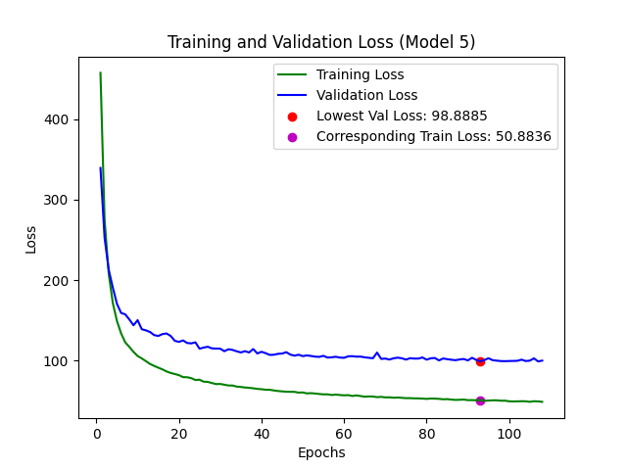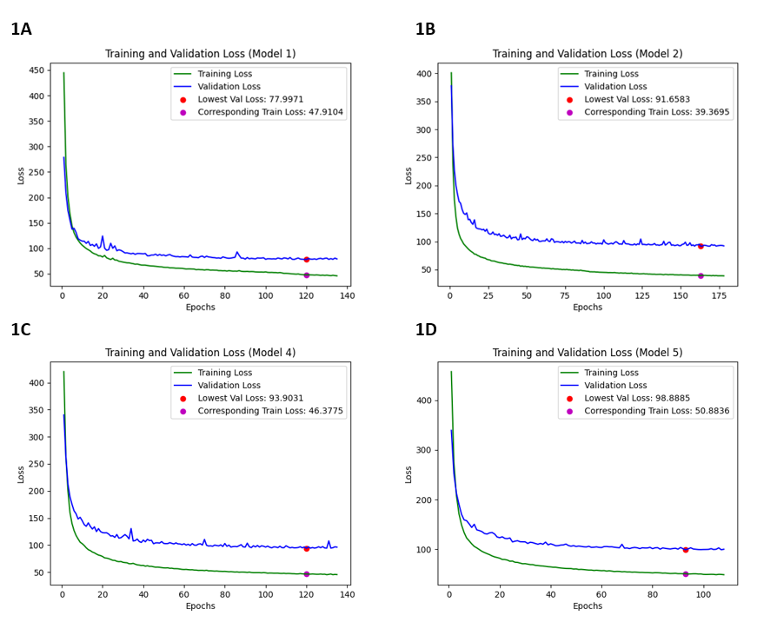

**8d**

**8b**

**8a**

**8c**

**8e**

*Figure 1: This shows 5 plots (a,b.c,d,e) representing the train and validation loss curves for an autoencoder model with the goal of reconstructing the same ECG the had been inputted in the model. The loss is based on mean absolute error and each plot , plots the recorded MAE for each epoch. The best val loss and the corresponding train loss of the model is stated in the legend as a best model was used based on the val loss therefore the model with the lowest val loss was being used even if the model lasted for more epoch. Each plot correspond to a model and each model tests for the corresponding fold e.g model 1 used to reconstruct for test 1 (fold1). More details on the train val test split can be found in the methods flowdiagram(figure1) .*  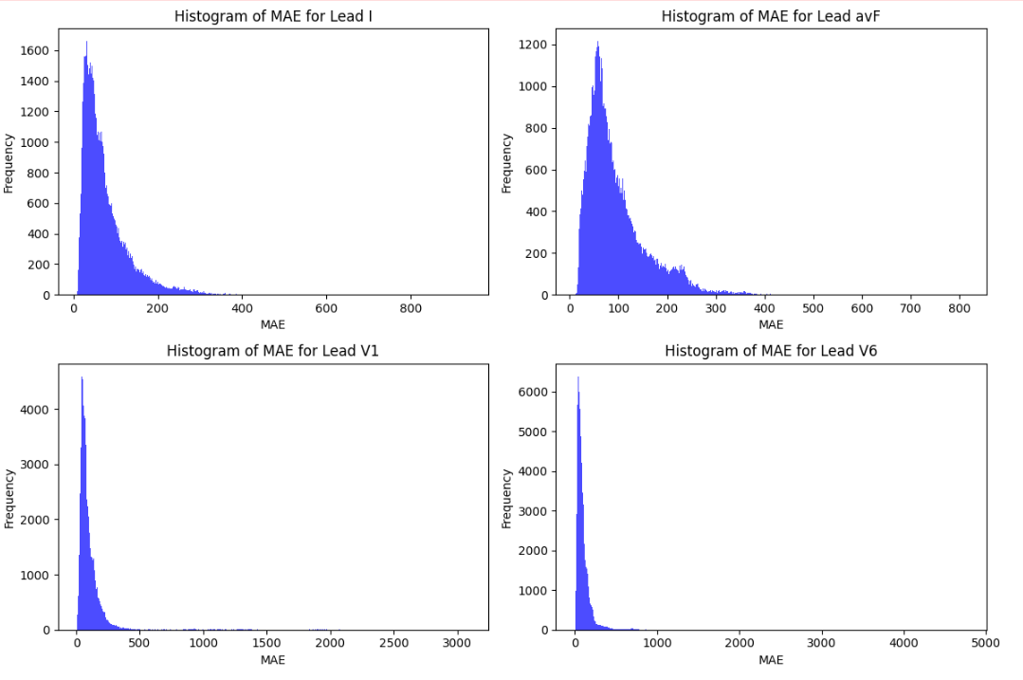 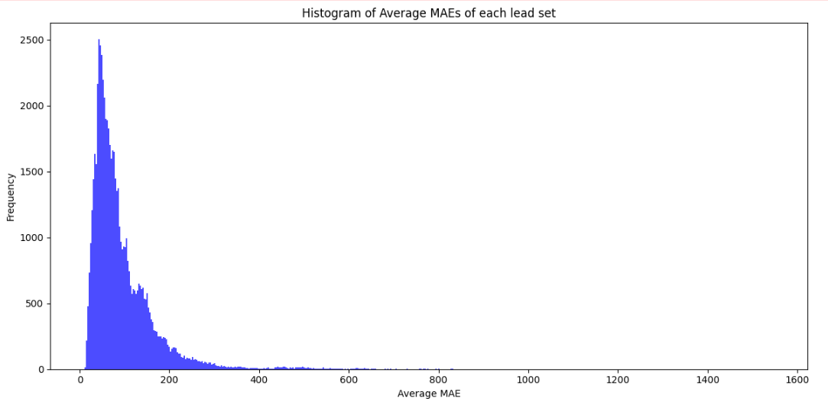

**9d**

**9c**

**9b**

**9a**

**9d**

Figure 2: This figure shows the distribution of the MAE loss for each lead, here a,b,c and d show the distribution of the mae loss for each lead for all the test sets 1,2,3,4,5 so in total all the 62,100 samples . Figure 2e shows the distribution for the average MAE for each set of leads I,avF,V1 and V6 together for each of the 62,100 samples.

We can see that the performance when it comes to the training and validation loss curve of the models overall is good for this task of reconstruction. The large improvements in validation and training loss occur within the first 20 epochs and there are then small incremental improvement after that(figure1). The models last for a relatively large number of epochs lasting to about more than 100 epochs(figure1). As for the distribution of MAEs we can see that while that it general the models produce reconstruction mostly between the 0-200 range this is seen in the total average MAE measurements and the individual lead reconstruction performance(figure 2).It is important to note some outliers larger than and MAE of 500 with the individual lead performance of V1 and V6 showing a MAE of up to 5000 however this is only for a small amount of samples between 20-60(figure2).

|  |
| --- |
| Original ECG |
|  |
| Reconstructed ECG: MAE 11.5  Figure 3: This plot shows what a good ecg reconstruction looks like . The plot are plotted in this order of lead I, avF,V1 and V6 . |
|  |
| Original ECG |
|  |
| Reconstructed ECG: MAE 610  Figure 4: This shows an original and reconstructed ECG for a bad reconstruction with a high mean absolute error : 610.3. |

Looking at both we can see that the reconstruction for an ECG that is clean with no noise performs very well. There seems to be a noise reduction effect on the ECG also in which the small bumps that represent miniscule increased in the signal between the peaks are removed and replaced by a smoothed outline in the reconstruction. This difference is evident in the actual avF and the reconstructed avF for the good reconstruction (figure 3). For the badly performing reconstruction when those small changed are slightly larger as seen in the original aVF lead, the model struggles to reconstruct the signal however it is able to reconstruct the QRS peaks. We also see the effect of noise on the reconstruction as the original V6 is improper and considered to be noise and this leads to a bad V6 reconstruction(figure4). It is of note the many signals above 400 MAE are dealing with noise in one of the leads, normally V1 and V6 , hence producing reconstruction responsible for those outliers seen in the distribution plots for the MAEs of the reconstructions(figure2).

# Autoencoder intracardiac rhythm reconstruction

**12a**

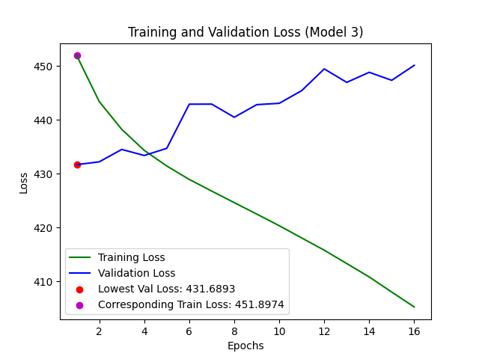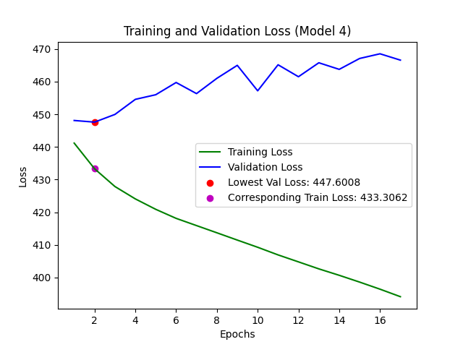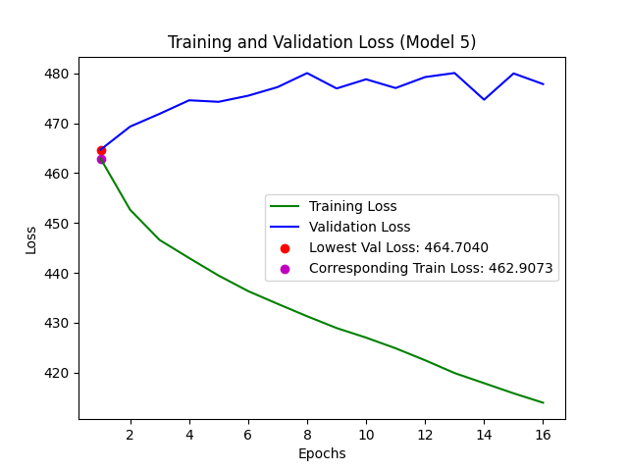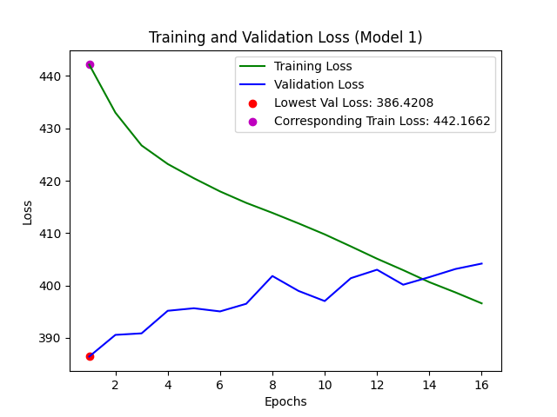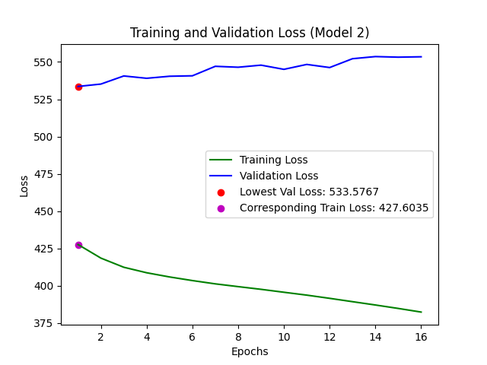` 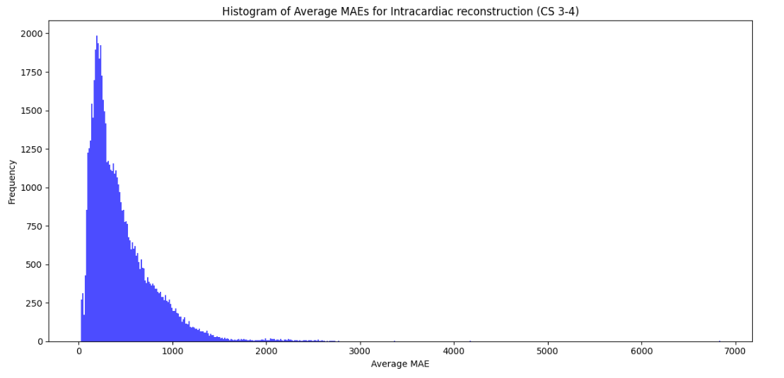

**12e**

**12d**

**12c**

**12b**

Figure 5: This shows 5 plots (a,b.c,d,e) representing the train and validation loss curves for an autoencoder model with the goal of reconstructing the intracardiac rhythm based on the ECG. The loss is based on mean absolute error and each plot , plots the recorded MAE for each epoch. The best val loss and the corresponding train loss of the model is stated in the legend as a best model was used based on the val loss therefore the model with the lowest val loss was being used even if the model lasted for more epoch. Each plot correspond to a model and each model tests for the corresponding fold e.g model 1 used to reconstruct for test 1 (fold1). More details on the train val test split can be found in the methods flowdiagram(figure1)

**5d**

**5c**

Figure 6: This figure shows the distribution of the MAE loss for each lead, here a,b,c and d show the distribution of the mae loss for each lead for all the test sets 1,2,3,4,5 so in total all the 62,100 samples . Figure 2e shows the distribution for the average MAE for each set of leads I,avF,V1 and V6 together for each of the 62,100 samples.

By looking at the train and val loss plots we can see that none of the models have performed adequately at all. In each model the more the model is fitted to the training set, represented by the decrease in training loss, the more the val loss disimproves(figure5). Looking at the distribution of the MAE most reconstructions fall between the 0 -1000 range with some outliers after the 1500 mark(figure6).

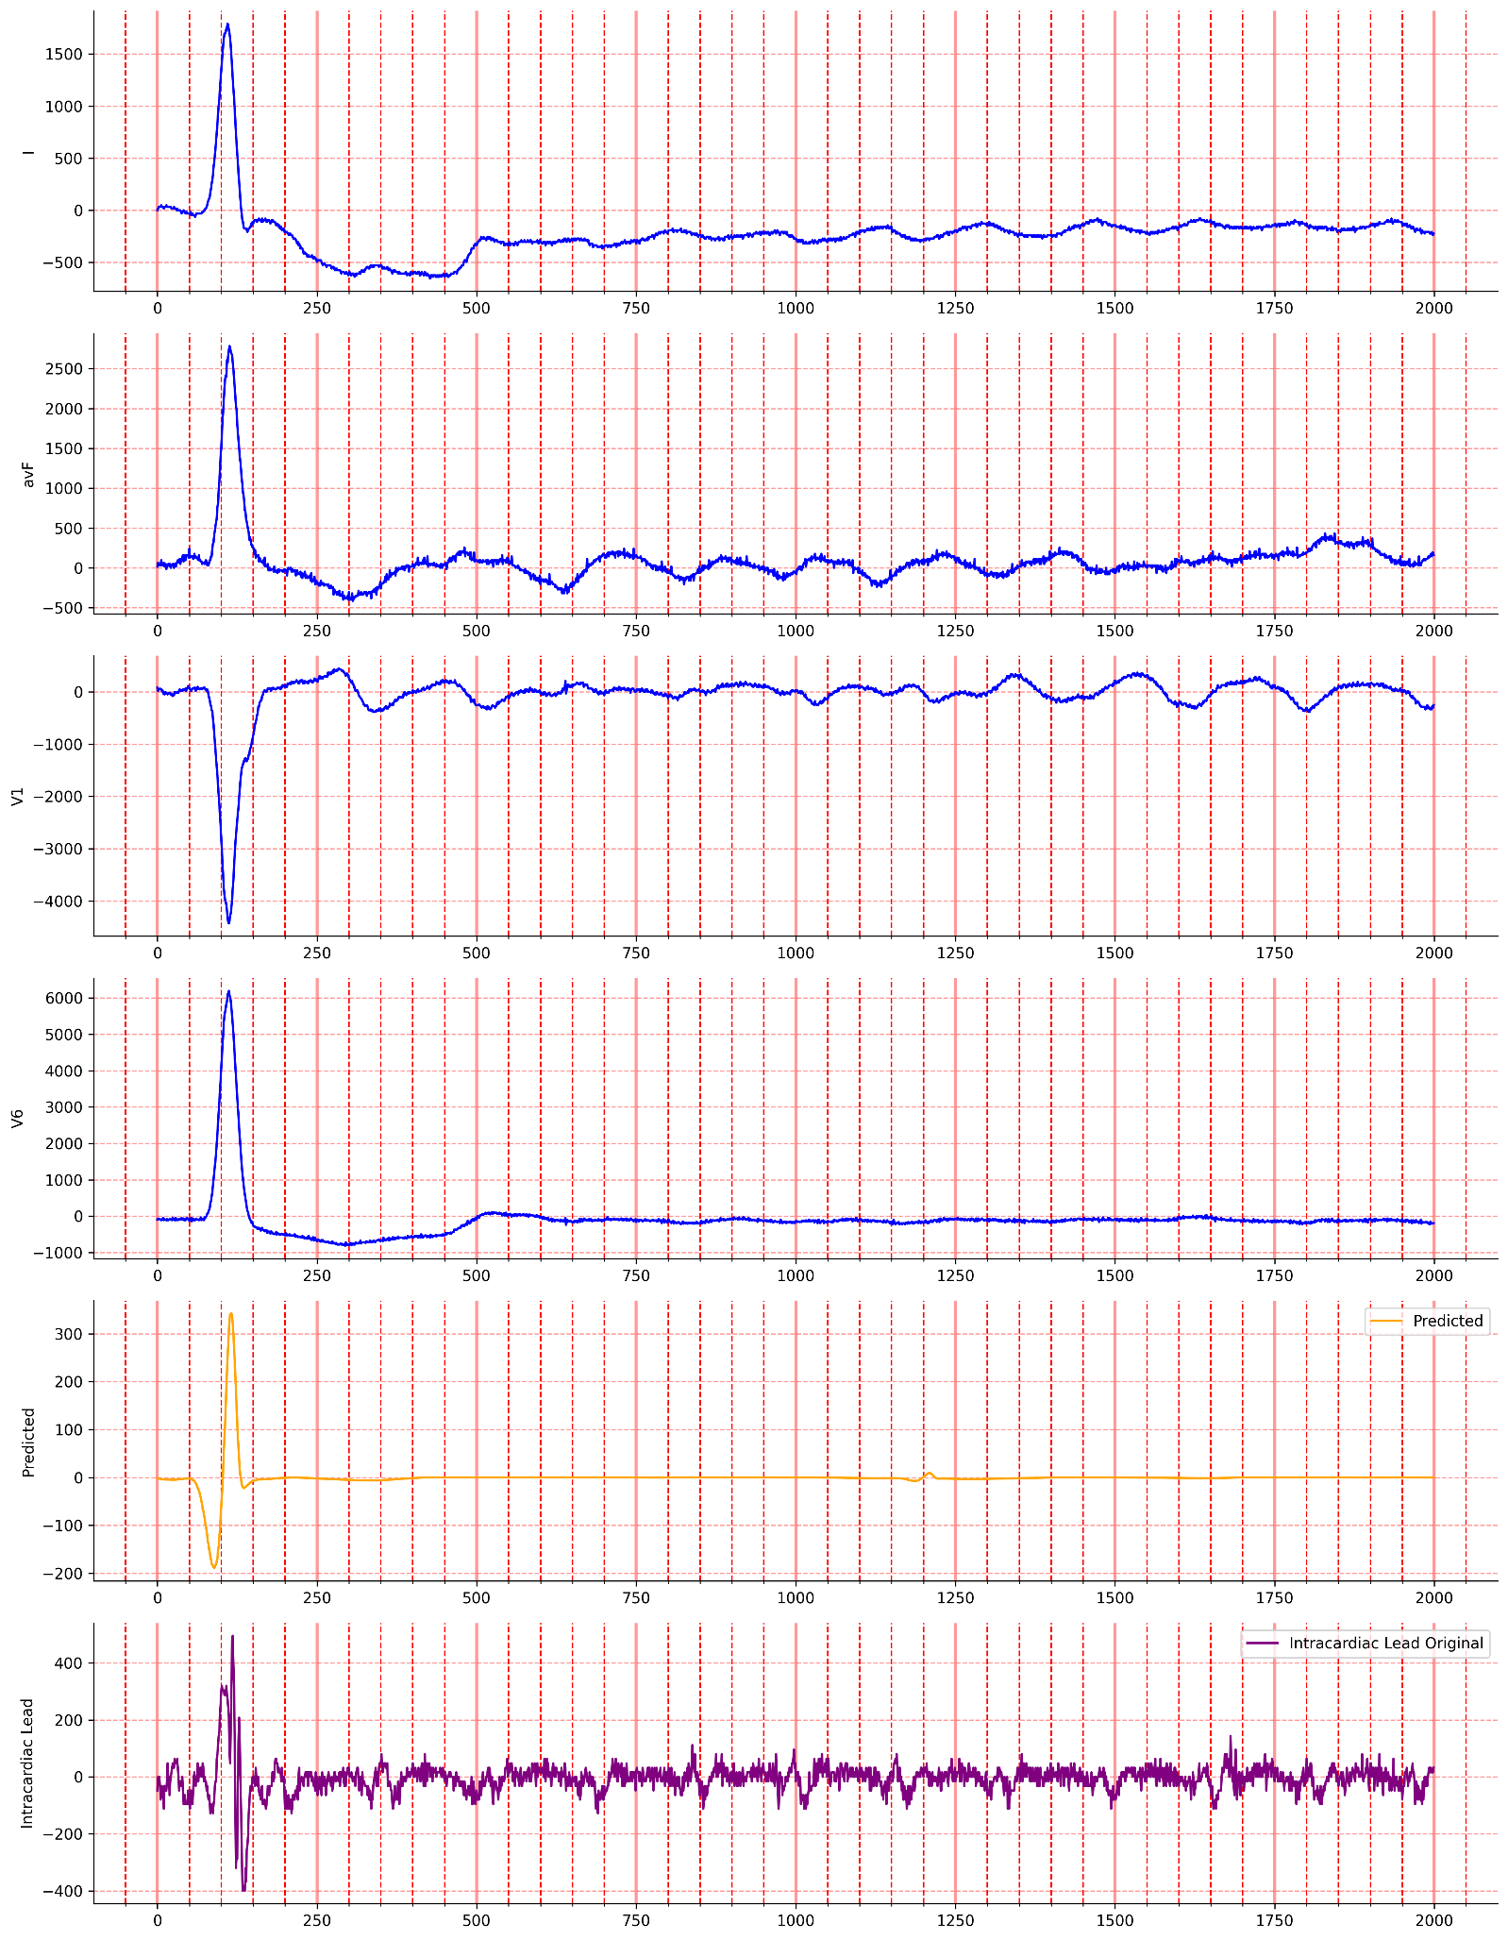

Figure 7: This is a well performing plot (MAE 24.64) . The plot shows the 4 ECG leads and the reconstructed intracardiac lead (predicted) and finally the original intracardiac rhythm plot is shows to compare with the predicted.

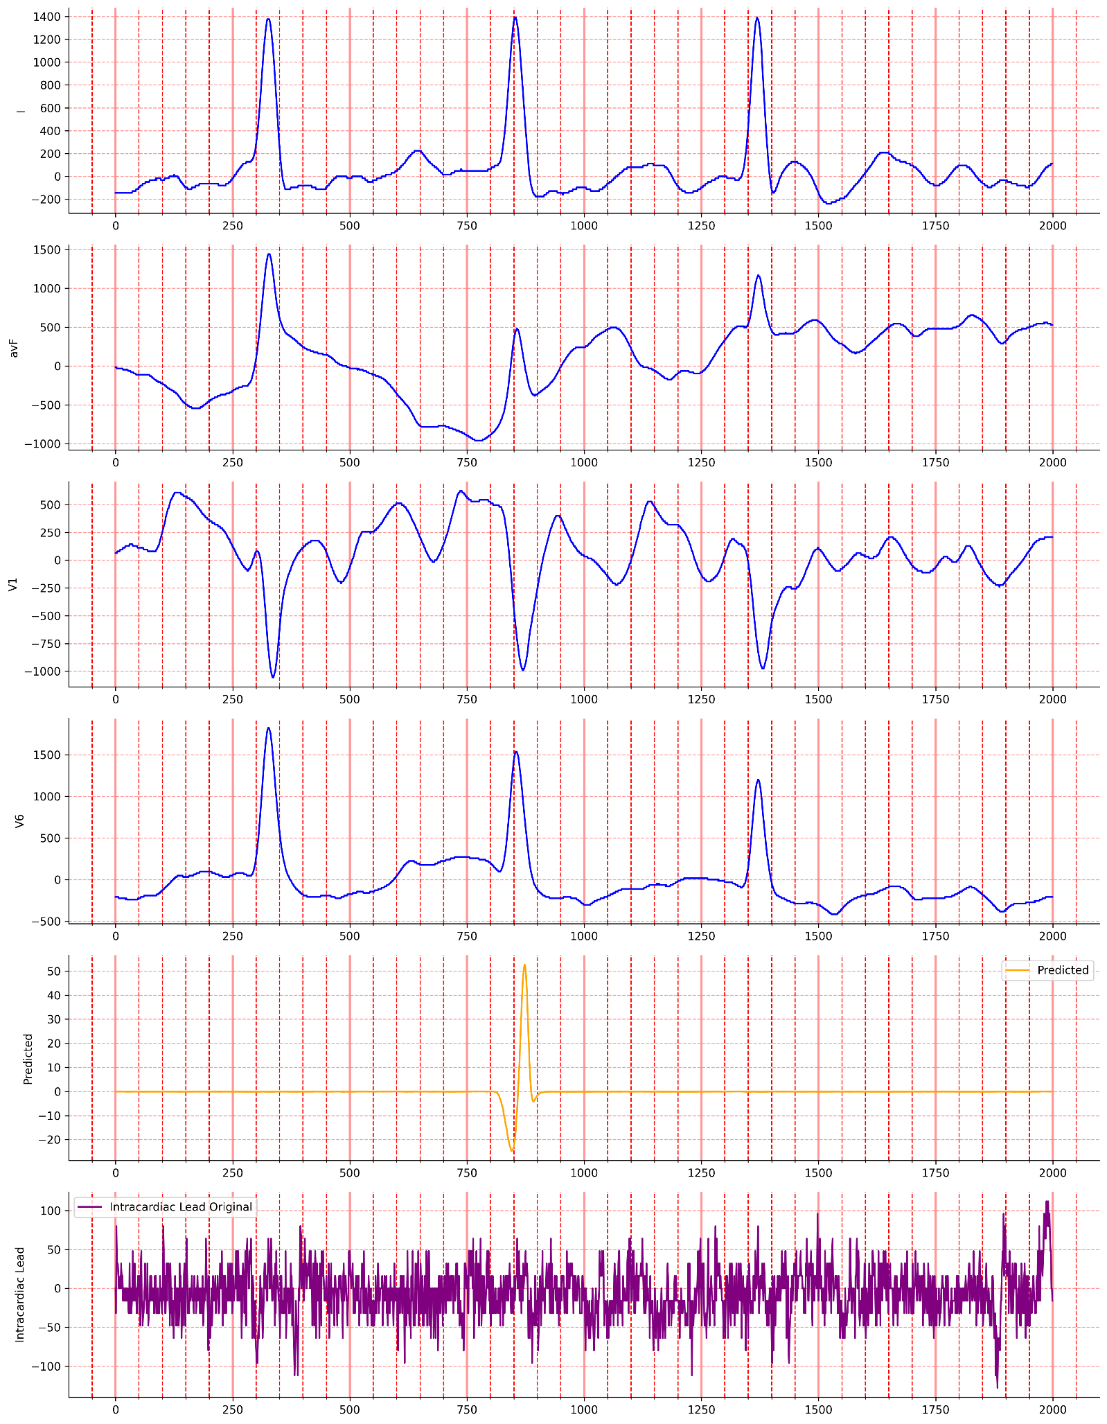 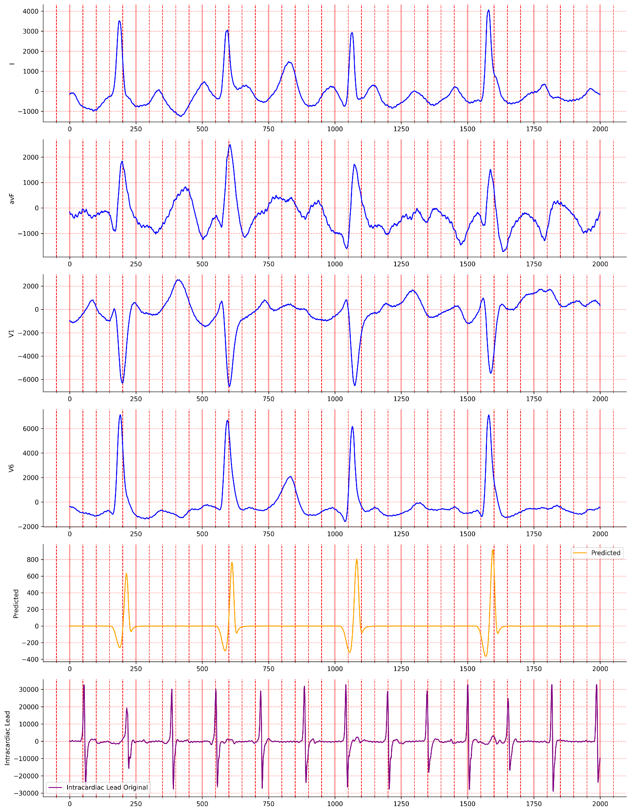

**15b**

**15a**

Figure 8: 8a shows a bad reconstruction visibly however the MAE is (24.6) and figure 8b just shows a poorly performing reconstruction visibly and based on MAE (2598.0)

For the good reconstruction we see how the placement of the QRS peak what is is being picked up well here however the details within that peak are inaccurate compared to the original signal also the erratic nature of the AF intracardiac reading before and after the QRS peak seem to not be captured at all. This a recurring theme among the well performing models where a smoothed out QRS is placed in the right place, but it does not capture any of the erratic nature of the intracardiac rhythm (figure 7). The predicted intracardiac that has a good MAE but performs badly visibly is interesting as the relatively small scale between -100 and 100 means that a MAE of 24.6 is actually a bad performance as opposed to a MAE of 24.6 at a larger scale (-400 – 400) which shows a better performing model (figure 8a). The final plot shows what a bad plot with a bad MAE (2598.0) actually looks like in which none of the QRS peaks are aligned properly and even the frequency of QRS peaks is not the same (figure 8b). It is also worth noting that the positioning of the QRS peaks is aligned with the peaks of the 4 leads influencing it rather than the intracardiac rhythm (supplementary 1).

# CNN for sample entropy performance

|  |  |
| --- | --- |
| Sample entropy performance model 1 | Sample entropy performance model 2 |
| Sample entropy performance model 3 | Sample entropy 4 performance model 4 |

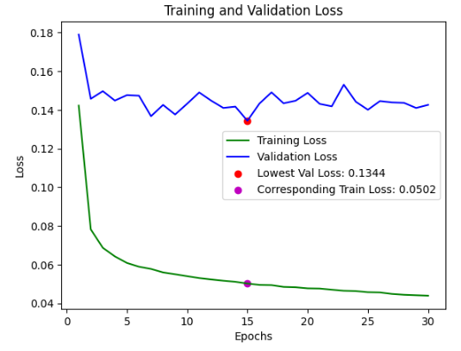Sample entropy performance model 5

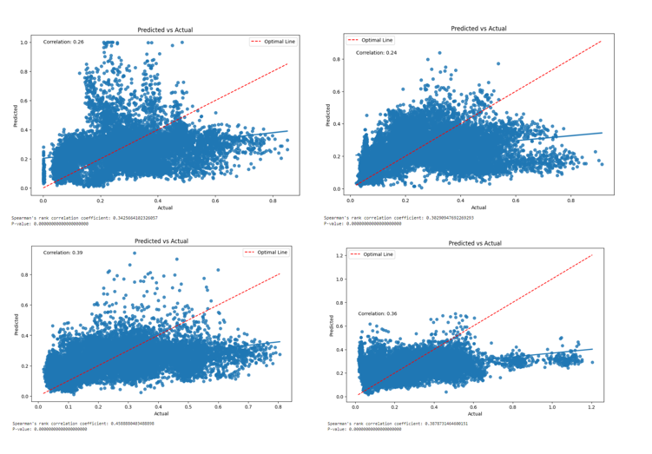 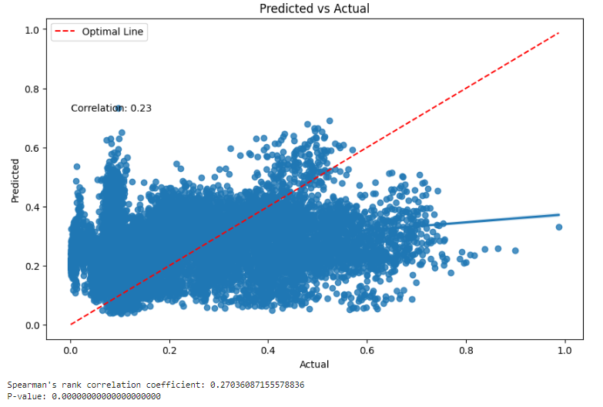

Figure 9: This shows 5 plots (a,b.c,d,e) representing the train and validation loss curves for an autoencoder model with the goal of predicting cross entropy of the intracardiac rhythm signal based on the ECG signal. The loss is based on mean absolute error and each plot , plots the recorded MAE for each epoch. The best val loss and the corresponding train loss of the model is stated in the legend as a best model was used based on the val loss therefore the model with the lowest val loss was being used even if the model lasted for more epoch. Each plot corresponds to a model and each model tests for the corresponding fold e.g model 1 used to reconstruct for test 1 (fold1). More details on the train val test split can be found in the methods flowdiagram(figure1)

**17b**

**17a**

**17d**

**17c**

**17e**

Figure 10: Threse are correlation plots which plot the correlation between the original values from the sample entropy and the predicted values for sample entropy. Plots a,b,c,d,e all correspond to a model : 10a(model 1),10b(Model 2),10c (model3), 10d( model 4 ) , 10 e (model 5) and all these models used SIGMOID as the activation function in the final layer.. The ideal correlation would be 1 in which the loaded and predicted values are exactly the sample this is represented by the optimal line (red dashed line) The correlation for each model in order is 0.26,0.24.0.39.0.26,0.23. In spearman rank p value is 0 for each which indicated all model perform better than a random guess of predicted sample entropies.

Model performance by correlation of loaded prediction to actual values

|  |  |  |  |  |  |  |
| --- | --- | --- | --- | --- | --- | --- |
|  | Model 1 | Model 2 | Model 3 | Model 4 | Model 5 | Total performance |
| Sigmoid | 0.26 | 0.24 | 0.39 | 0.26 | 0.23 | 1.38 |
| Soft plus | 0.21 | 0.15 | 0.29 | 0.23 | 0.21 | 1.09 |

*Table 1: This table shows the performance of two activation function that have been used on the final layer of the same model for predicting sample entropy. The model was evaluated based on the correlation between predicted sample entropy (loaded predictions) and the actual sample entropy values.*

The models seem to have a optimal MAE that lies between 0.11 and 0.13, while most the models do see a decrease in the validation loss as the model is fitted more to the train data model 1 seems to not see any decrease and rather the val loss increases(figure9). Model 1 also has many predicted values that hit a ceiling of 1 , this is because the sigmoid function only outputs values from 0 to 1 (figure 10a). While a soft plus function in theory should be better suited to this task as it can be trained and outputs values greater that are positive and not within a range of 0-1, we opted to focusing on the sigmoid activation function as it performs better than the soft plus activation seen in the total performance improvement of 0.29 over the total performance of the soft plus activation function(table1). My looking at the plots the best performance for the model occurs between 0 and 0.4 sample entropy values as seen by the larger accumulation of values around the optimal line compered to with the values go over 0.4 in which much less predicted values intersect with the optimal line (figure 10). Overall, the performance is quite poor for predicting sample entropy using ECG as the total performance is 1.38 out of the possible 5 and none of the correlation seen are over 0.4 which will result in a weak set of features to be extracted that are not indicative of effective features that can truly predict cross entropy from a 4 lead ecg reading.

# Clustering

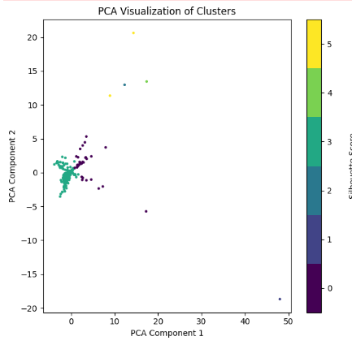**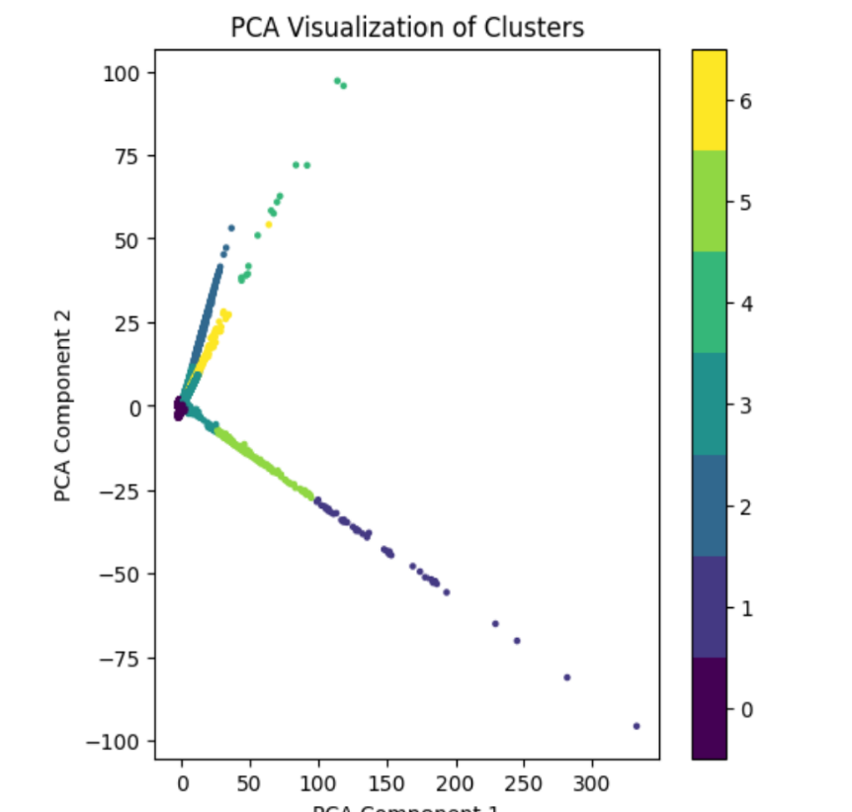

**18a**

**18b**

*Figure 11: This figure shows the clustering of a set of features extracted from a model predicting the sample entropy for the test set corresponding to each model. The optimum amount of clusters has been picked with the elbow method. Each plot is a pca plot and therefore involves a dimensionality reduction of the features into two components before plotting. 11a uses all 62100 samples and therefore 285 unique patients and there pre and post samples to cluster on resulting in 7 clusters. 11b shows a cluster of per patient analysis this uses one sample based on the median cross entropy from each unique patient (285) .*

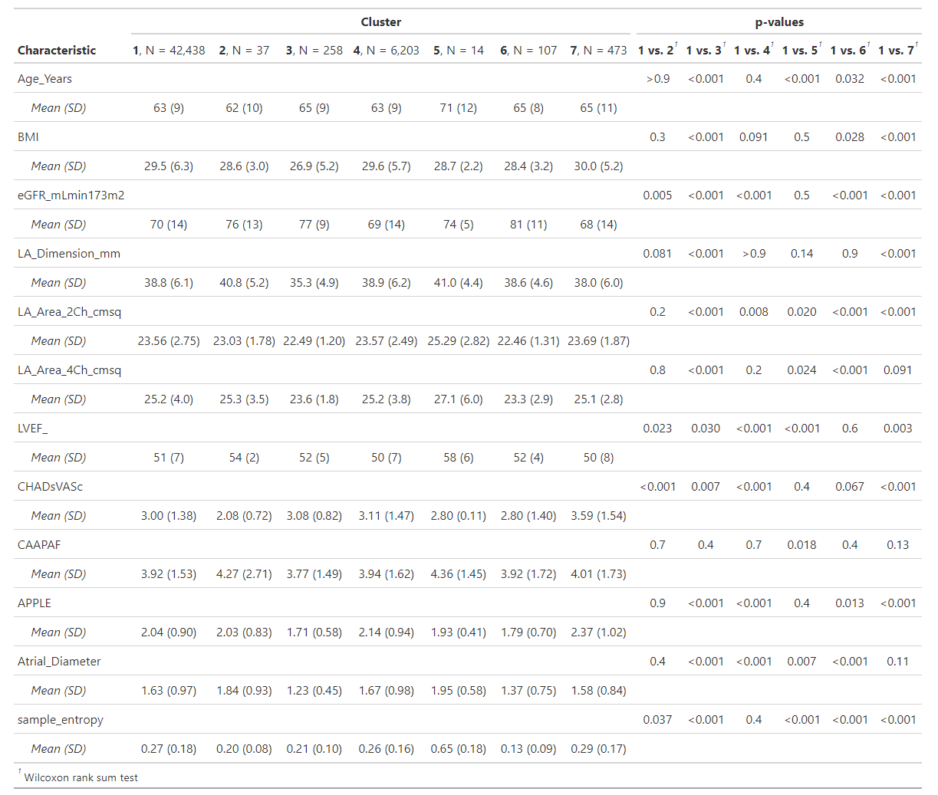*table 2: This table shows the mean and standard deviation from some of the numeric variables that where clustered on. The red boxes represent a Bonferroni corrected significance of 0.00714 so anything under this number is still considered significant. Some labels are not clear so I will detail them now eGFR_mlmin_173m2 stands for (eGFR(mL/min/1.73^2) which stands for the estimated glomerular filtration rate. LA here stands for the left atrium .LA dimension is the size of the atrium in mm .LA_area_2ch_2msq and LA_area_2ch_2msq are related to the atrial volume. LVEF_ is LVEF (%) which is Left ventricular ejection fraction percentage. CHADsVASc is a score that can suggest treatment based on a score up to 9. CAAPAF is a score for treatment as well. APPLE score is another score that is used to predict how likely a recurrence will help especially for patient with repeat ablation.*

There are many insinuations we can make from this data as clearly there are a lot of significant differences between the cluster as you can see from the vs values being 1 vs another cluster and we see the difference between cluster one and this other groups. Seeming as though cluster 1 is the largest cluster and has every patient in them it serves as a good comparison as we compare how all the patients’ characteristics are distributed compared to a smaller set of patients in the other clusters. When we look at the cohort as a whole through cluster 1 it is easy to recognise that these patients in general are much older and on average at least overweight (BMI over 25) so we are dealing with a cohort that is already at higher risk of comorbidities than the average population hence why catheter ablation has been undertaken for all the patients. There is no healthy control group here as really as you would have to be at risk to get a catheter ablation in the first place. We can see how the differences between sample entropy is significant showing that sample entropy is significant in deciding cluster assignments in which cluster 5 seems to have the largest sample entropy values on average. It makes sense that the sample entropy is a big cluster decider as the model were trained on predicting sample entropy from ECG reading so the features are geared towards sample entropy in general. It has been interesting to see what type of patients fall at a the lower end of sample entropy (cluster 6) compared to patients that have features that seem to be common in a higher level of Sample entropy (cluster 5). For cluster 5 which has a higher sample entropy , it is interesting to see that compared to the first cluster the only things that are significantly different is age ( 71 which is the highest mean age) , LVEF % and atrial diameter in which it has the highest mean out of all the groups for all three of those factors indicating that these are some of the most important factors in resulting in a higher sample entropy. In contrast, cluster 6 shows significant higher levels of egfr compared to cluster one which indicate better kidney function, and low la volume as indicated by low 2ch and 4ch values and finally a smaller atrial diameter. All these factors are related to reduced cardiovascular risk suggesting that lower sample entropy maybe indicative of a relatively healthier cohort compared to a higher sample entropy. This is backed up with cluster 3 which also a significantly lower sample entropy compared to cluster one and has the lowest BMI, la dimension and atrial dimeter between all the clusters. Also when looking at another cluster (cluster 7) which has a significantly higher mean sample entropy (0.29) we also see a higher risk cohort which has the highest BMI score , scored the highest in every risk score in which its APPLE score (recurrence) and CHadsvas(cardiovascular risk score) are significantly higher than in cluster 1. and had the lowest eGFR. There is not much to note about cluster 2 , it also has variable values that suggest a cardiovascular risk like a high atrial diameter of 1.84 however compared to cluster 1 there are no significant differences that stand out other than a higher eGFR and lower chadsvac.

Now looking at the scores the APPLE score and CHAdsvac seem to be good a differentiating between cluster 1 and 2,3 and 7 however where not effective in differentiate between the clusters with the large differences from cluster 1 being cluster 5 and 6. In addition to this the CAAPAF is not successful in differentiating between cluster 1 and any of the other clusters and is the only score with no significant differences can be seen.

Overall while scores like CHadsvac and APPLE are good differentiators of the clusters, the clusters with at more extreme ends of these risk factors like 5 and 6 require looking at more of the risk factors like la volume, atrial diameter, LVEF and egfr to get a better understanding of what really differentiated these clusters from each other. It is now useful to look at the categorical variables which include comorbidities, drug and ablation treatment options to see if we can identify different treatment methods for this group. These results also have provided some optimism in recognizing that even with a subpar predictive performance we are still able to establish and identify clusters with differing characteristics to one 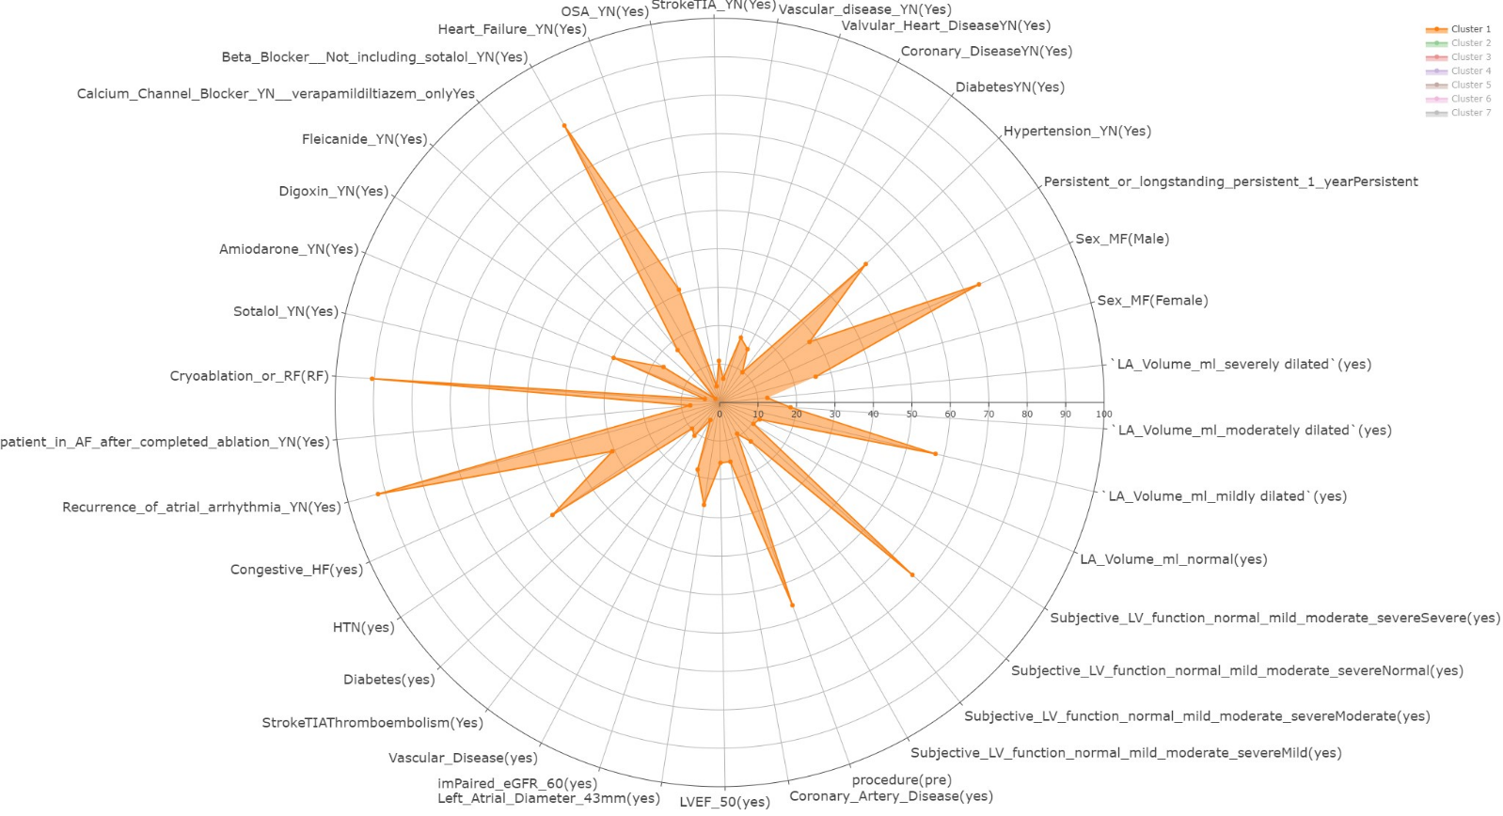another.

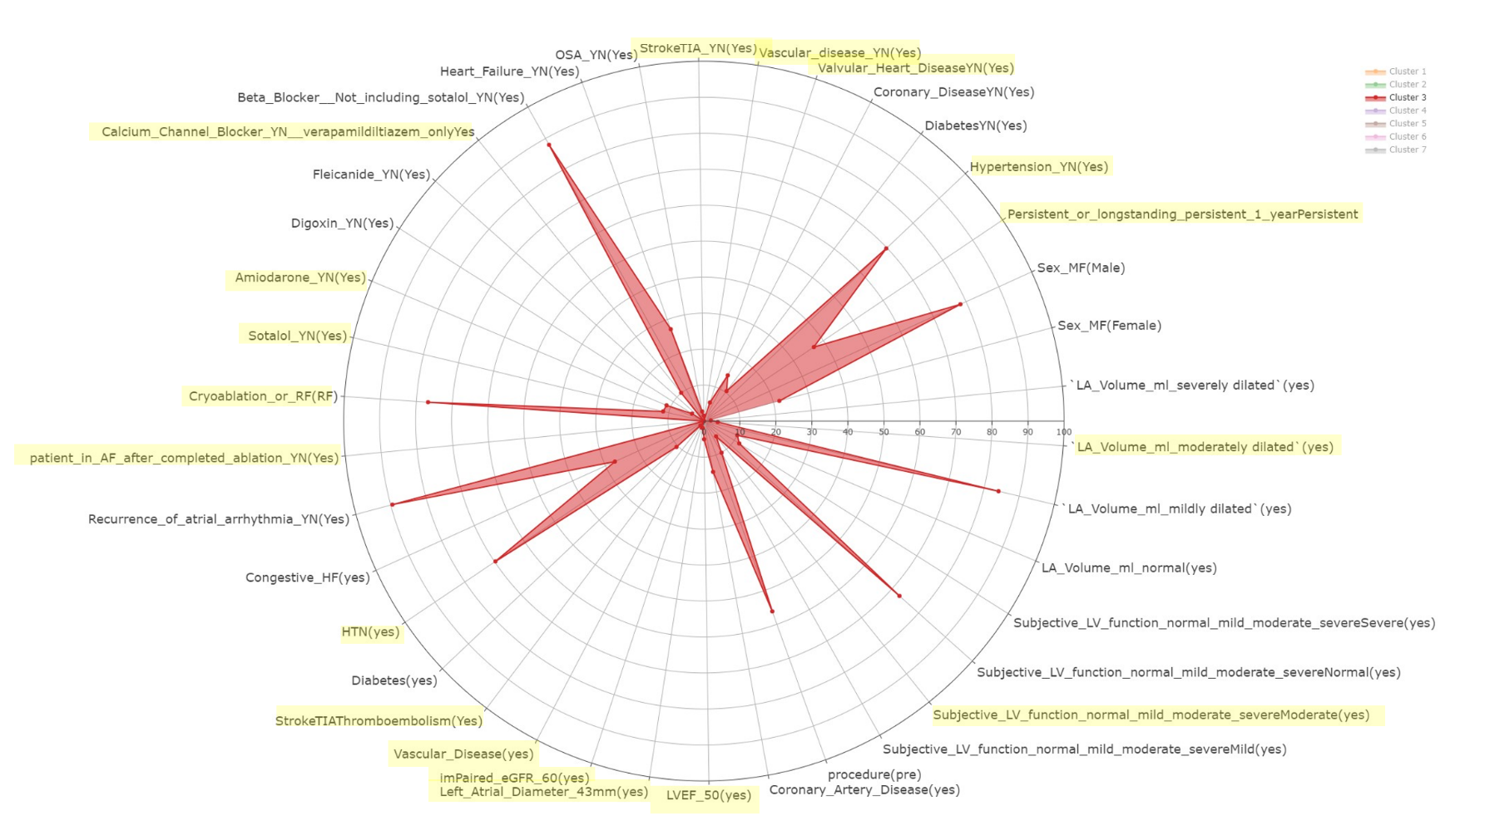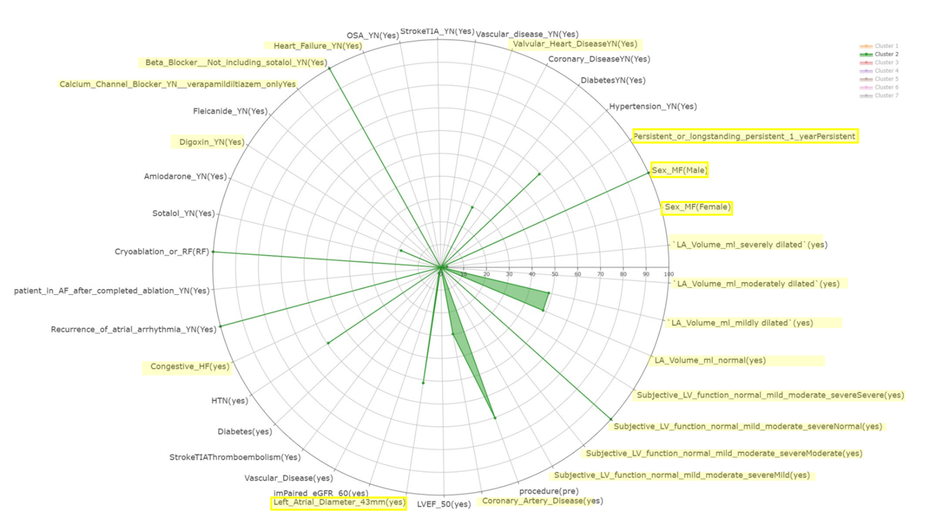 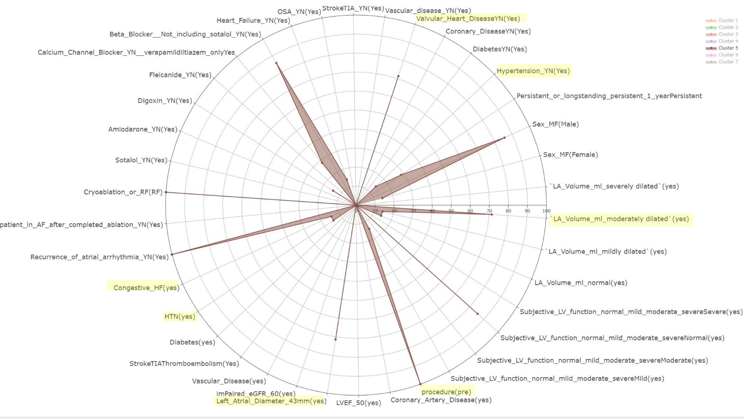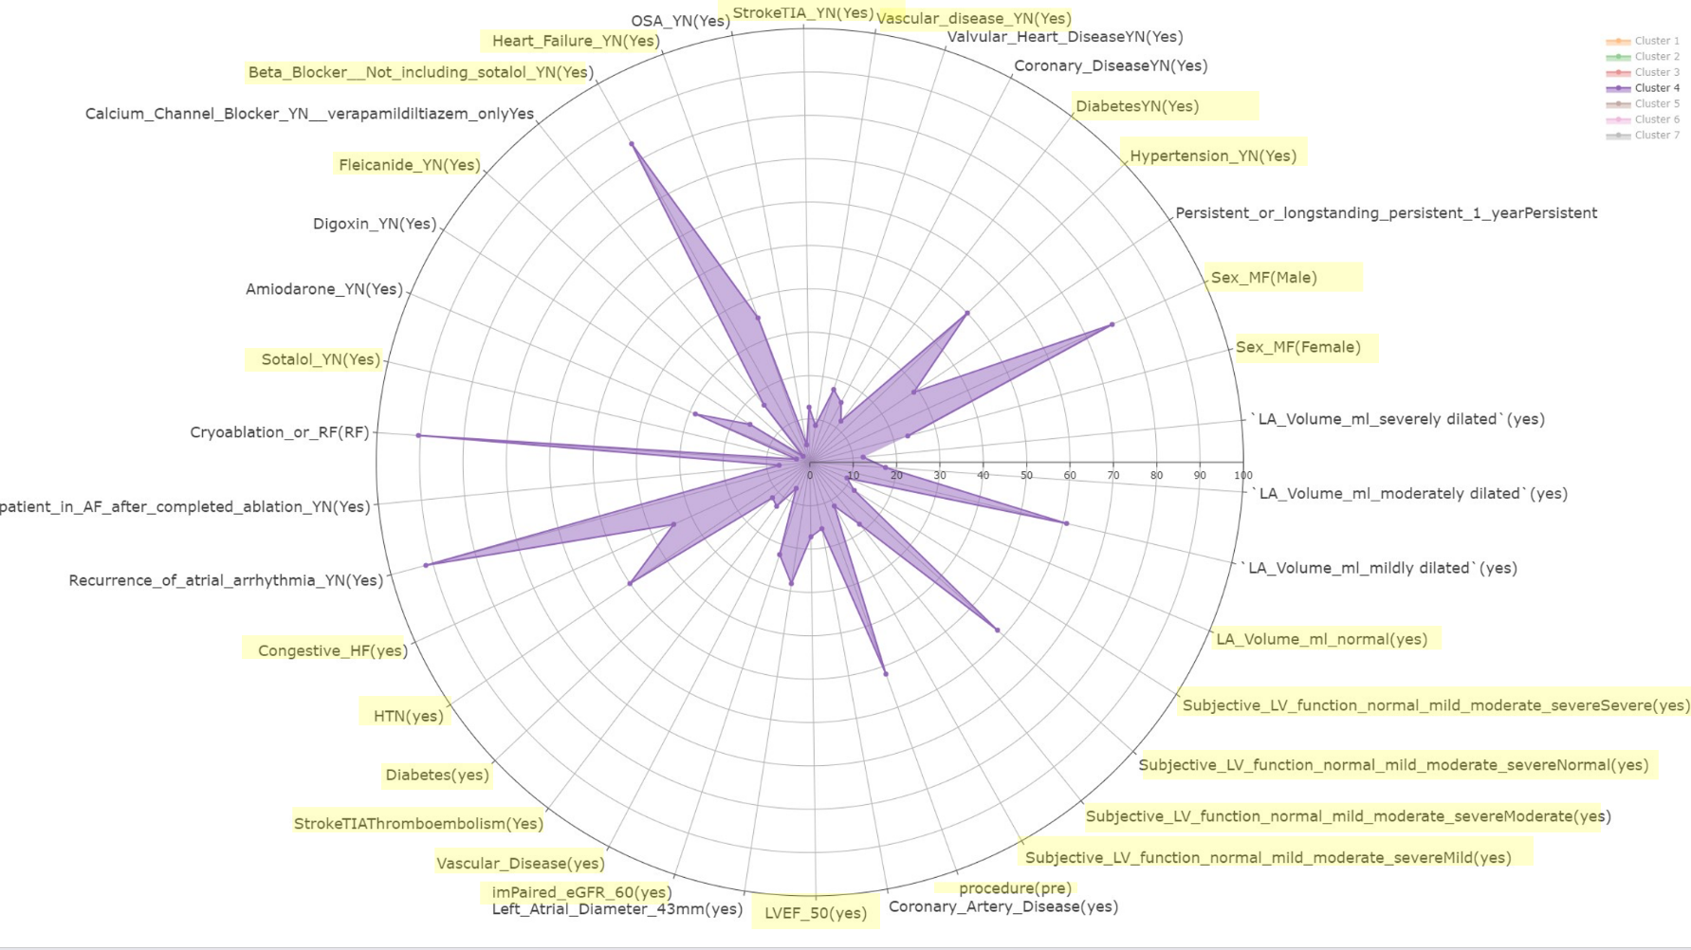

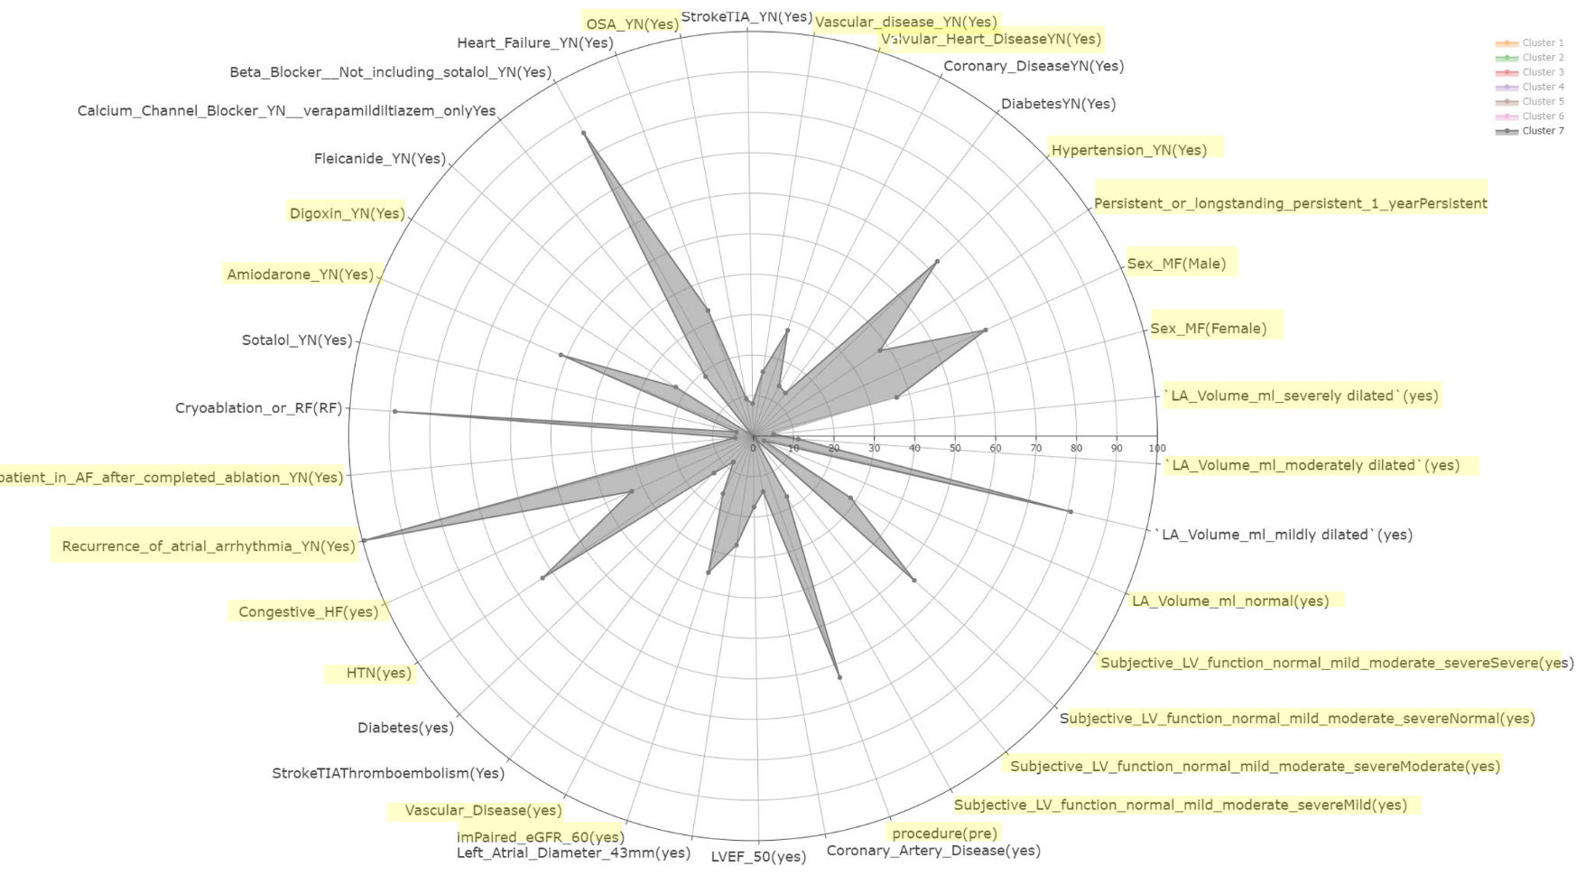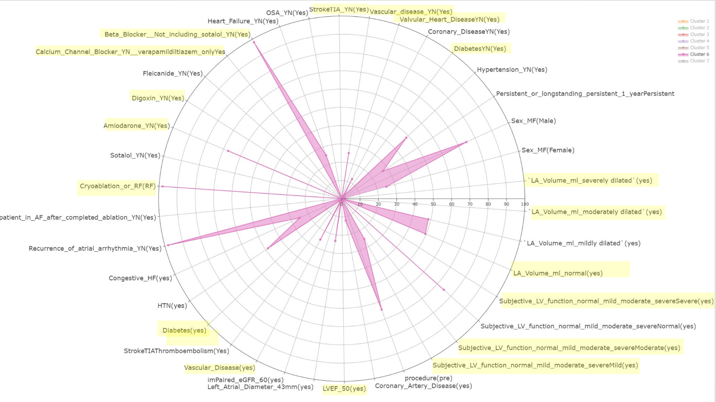

Impaired egfr under 60

Htn hypertension results are the same.

Lvef under 50

Left atrial diameter over 43 mm if under then good

# Analysing the factor data

Looking at the drug history of the participants in all clusters it evident that in general a low amount of participants have any drug history beyond taking beta blockers and artefact of cohort being composed off people with cardiovascular risk factors and comorbidities as a common medicine to deal with arrhythmias is beta blockers which is above 80 percent for any cluster. Another commonality from the clusters is that most people went through RD ablation rather than cryoablation with most clusters other than cluster 3 having over 90 percent of samples had RF ablation. Cluster 5 as we have seen before was characterised by having the largest atrial dimensions like diameter , and la dimension and these maybe linked to the fact the cluster has the highest percentage of sample with valvular disease at 71 percent which is 53 percent higher than what we see in cluster 1 and in addition it has significantly higher percentage of sample that show a left atrial diameter of over 43mm at 71 percent which again is the highest amount among the clusters.. However, cluster 5 does have the lowest level of hypertension (14%) and congestive heart failure (14%) which suggests that the enlarged dimensions could be due to the valvular heart disease. Finally for cluster 5 100 percent of the sample are pre catheter ablation giving us an idea of what a higher risk cohort may look like before catheter ablation. In contrast cluster 6 contained samples with relatively lower values for those risk factors linked to atrial dimension and we see within this cluster that these samples have the lowest number of samples with valvular disease at 0 percent which is significantly less than cluster 1. There are other factors that show a reduced risk compared to cluster 5 like la volume being significantly more normal than cluster 1 as 50 percent of sample had a normal la volume which considering other clusters other than cluster 2 have a very low percentage of people with normal la volume not going above 11 percent in addition to this non of the samples belong to participants with moderately dilated la volume and on 1.9 percent are severely dilated these both are also significantly lower than the la volume levels in cluster 1.Other comorbidities like diabetes are also significantly lower that cluster 1. Cluster 6 also has the highest level of samples that are linked to taking amiodarone at 67 percent in addition to beta blockers at 98 percent. As far as drug history this where cluster 5 had drug history only linked to beta blocker cluster 6 showed a significant amount of amiodarone usage ad 67 percent another medicine linked to reducing disease. Cluster 3 had the lowest la dimension, atrial diameter and this is backed up here by thee sample in this cluster having a significant lower level of left atrial diameter of 43 mm , low level of impaired egfr and a low level of stroke however the samples seem to have a high level of hypertension at 70 percent. What is also interesting in this cluster is that is has the most and a significant amount of sample that underwent cryoablation at 23 percent while most clustered heavily favoured RF in which cluster 3 has no AF after ablation and while not significant It has the lowest level of recurrence of arrhythmia out of the clusters which as significant between cluster 3 and 5. Cluster 7 also showed significantly higher sample entropy mean a low LVEF percentage at 50 perenct mean , this leads to some interesting results as subjective lv function being sever is signicantly higher in this cluster,an is the highest among all the clusters at 29 percent while all the other clusters have a severe function in 12 percent of sample or less sometimes 0 in the case of cluster 6. In terms of drug history there for cluster 7 the levels of digoxin use and amiodarone are also significantly higher that cluster 1 and other cluster other than cluster use which shows high percentage of amiodarone drug use. Cluster 2 which has no significant differences other than atrial dimater gives us more insight when looking at some categorical risk factors. Cluster 2 has significantly higher amount of samples with longstanding afib samples being at 100 percent. Based on we can have an idea in what crticical factor make a patient longstanding and here we signicantly high percentage of left atrial diameter being over 43 percent and high percenetage of sample with cornorary artery disease also the la volume is signifanctly all cases showing that long standing afib is linked more to atrial conformation than la volume.

# Discussion

* While the autoencoder intracardiac rhythm reconstruction performance was deemed inefficient enough for feature extraction there was still some promise when looking at the use of CNN to predict sample entropy a much simpler task.
* The CNN task also resulted in a performance that was considered less than ideal with correlation score of less than 0.5 in spite of this we are able to establish some unique clusters based on changes in mean sample entropy of each cluster which is what these features were directed towards.
* We have decided due to limitation in patient number to look at cluster 1 as a reference cluster and while not ideal a per sample analysis is still effective in identifying cluster. This is because for example cluster 1 had every participant in it however some participants had samples repeated more than other therefore making there features more influential in determining the mean therefore based on this we are able to get insight of how the patients are distributed in each cluster and what feature stand out by looking at mean.
* My using cluster 1 as a reference cluster we can identify how some clusters differ when it comes to sample entropy and what changes in this result in. We begin to recognise that lower sample entropy are correlated with lower risk in some variables for example a smaller less enlarged atrial dimeter or la volume that is more normal or mildly dilated rather than being moderately or severely dilated this is contrast in clusters with a higher mean sample entropy which tend to have sample with a larger atrial diameter and other variables that pose a greater risk to atrial fibrillation. In addition, these larger entropy clusters seem to have a larger percentage of sample related to a fib comorbidities like diabetes, congestive heart failure and valvular disease.

## Phenotype analysis

* The first result that is of interest is that there is promise in establishing new phenotypes based on sample entropy and we have linked this to certain risk factors, comorbidities and in some cases drug history. By looking at our clusters there seems to be a difference in risk factors when it comes to clusters with samples with a significantly higher of lower level of sample entropy, only cluster 2 and 4 do not show significant changes in sample entropy and therefore are not necessarily the focus of our phenotype analysis. Researchers have previously established that sample entropy is a good way of characterising the complexity of ECG to the point where they are able to differential between patients with AF and without, so it is useful to be able to add to this concept by differentiation patients in more detail when looking solely at people with high risk AF( persistent or longstanding) [(Horie](https://www.ncbi.nlm.nih.gov/pmc/articles/PMC5871726/) *[et al.](https://www.ncbi.nlm.nih.gov/pmc/articles/PMC5871726/)*[, 2018).](https://www.ncbi.nlm.nih.gov/pmc/articles/PMC5871726/)
* ~~Looking at the cohort it is quite hard to differentiate between the clusters by looking at what cluster has healthy features compared to what cluster is at risk as the whole cohort is in generally at high risk so things like BMI ( which is linked to CVD risk) , high age (which also is linked to increased CVD risk) and eGFR which lower than average in each cluster given that the average when you are between 60-69 is 85 in which the clusters fall below this . So in general when we refer to these clusters and we decide to look at reduced risk as all patients are suffering from comorbidities and risk factors hence why they are undertaking catheter ablation therefore we have analysed these clusters based on a relative increased or decreased risk compared to other clusters rather that labelling one cluster as healthy and another as not healthy as that would convey an inaccurate assessment of the cohort as a whole and the clusters.~~
* The first clear difference between the higher risk high sample entropy and the lower risk low sample entropy clusters is the difference in atrial conformation, in general there is a higher mean atrial diameter, and a greater percentage of samples seem to be suffering from an enlarged atrial diameter of over 43mm and dilated left atrial volume. This is a first sign that patients that have sample within this higher entropy range are at higher risk as a enlarged left atrial diameter has been linked to higher level of AF recurrence after ablation which is what we see as while the recurrence of arrhythmia is high in all the groups , the clusters with high sample entropy like cluster 5 has arrhythmia recurrence of 100 percent after catheter ablation [(Zoni-Berisso](https://academic.oup.com/europace/article/20/1/33/3748226) *[et al.](https://academic.oup.com/europace/article/20/1/33/3748226)*[, 2014).](https://academic.oup.com/europace/article/20/1/33/3748226)
* As mentioned left atrial volume was another difference between the low sample entropy and high sample entropy group however the differences where not as large as opposed to the differences between la diameter however dilated atrial volume was still more common in higher sample entropy cluster. Previous research again has linked dilated left atrial volume to higher risk of cardiac hospitalization for people underwent atrial fibrillation indicating that if we can link someone to this through predicting sample entropy we can identify people at higher risk of rehospitalization and recurrence [(Wen *et al.*, 2022).](https://www.onlinejase.com/article/S0894-7317(22)00145-6/fulltext#secsectitle0040)
* From these clusters we can establish two new phenotypes with lower sample entrop while both are characterised by relatively better atrial conformation, and significantly reduced levels of comorbidity what separates them from each is their BMI which is much higher in cluster 6 and their proclivity to drugs use for treatment where cluster 6 has a higher amount of beta blocker and amiodarone use that cluster 3. Out of the two clusters it can be argued that cluster 3 is less at risk as it has the smaller atrial dimater , much less percentage of samples with enlarged atrial diameter and a smaller la dimensions.
* We can also establish two new phenotypes using the higher mean sample entropy clusters which have a greater risk of tachycardia when look at the the fact that more significantly more sample for both cluster 5 and 7 have a enlarged left atrial diameter and valvular disease however what separated them is that cluster 7 has a hugher amount of comorbidities (hypertension anc congestive heart failure) and had a higher amount of people with an impaired glomerular filtration rate .
* Something that stands out when looking at the clusters overall is the lack of a diverse drug history. Most patients in the clusters are assigned beta blocker which does make sense as they are deemed effective in bringing sinus rhythm to normal levels (Kühlkamp *et al.*, 2002). However while beta blockers seem to be the standard for preventing cardiomyopathy due to atral fibrillation they are less effective and may have adverse effects with people who have a high ejection fraction and that are already in AF .This is something that we see in these clusters in which everyone here has AF but the majority have a LVEF(lv ejection fraction) higher than 50 percent so using beta blockers may not be as effective and rather may cause adverse effects to the patients([Meyer and Lustgarten, 2023](https://academic.oup.com/europace/article/25/2/260/7030538)).
* Another drug of interest is amiodarone which is linked to reducing the number of sites that require ablation during pulmonary vein isolation catheter ablation [(Miwa](https://pubmed.ncbi.nlm.nih.gov/24446509/) *[et al.](https://pubmed.ncbi.nlm.nih.gov/24446509/)*[, 2014](https://pubmed.ncbi.nlm.nih.gov/24446509/)). It cluster 6 which has the lowest sample entropy, we identified that amiodarone use was highest in this cluster furthermore being linked to lower sample entropy however AF recurrence was still high at 98 percent but none of the patients where in AF after the surgery. It is of note that there are other cluster with 0 percent AF after catheter ablation so that have low amount of amiodarone use so it is not the most significant factor it causing a successful Atrial fibrillation also it clearly does not deal with the high AF recurrence.
* Other drugs like flecainide where used at a very low amount but there is no evidence by looking at the clusters or through previous research that this can reduce averse events like tachycardia of hospitalization after AF [(Hayashi *et al.*, 2014).](https://pubmed.ncbi.nlm.nih.gov/24706088/)
* Given the poor performance of drugs to prevent recurrence or to treat AF initially it is clear there must be research in finding new novel treatments to treat AF instead of looking for a drug or ablation method that is effective it may be useful to find a paring of the two that is effective in dealing with AF with catheter ablation then reducing recurrence through drug intervention rather than evaluation results of both drug and ablation based treatments separately which is what we normally see in trial like the CABANA trial[.(Poole *et al.*, 2020)](https://www.ncbi.nlm.nih.gov/pmc/articles/PMC8064404/)

# Evaluating the practicality of this solution

* There are many hurdles to overcome leveraging these new phenotypes in a healthcare setting. The first which shall be discussed further later is that these methods are reliant on being able to generate a robust set of features that is able to predict sample entropy. In this case we are not able to predict sample entropy sufficiently as we can see in the model performance. This bares the question if the clusters and result will change in a situation where the models perform more adequately therefore producing a set of features that can better predict sample entropy. This is not to invalidate the current results as we have extracted an outline related to risk and sample entropy, but more accurate performance can help us develop a more robust set of clusters.
* Another question is how this research can be used in the future. As of now the information available here can not inform current healthcare treatment but the new phenotypes we have suggested can help inform researcher looking into the topic. The reason why I believe this data is not yet suitable for a healthcare setting is that most the cohort still has a high level of recurrence in arrhythmia after catheter ablation so freedom of arrhythmia using the methods clustered on here is not an option and we have not established a cluster that has a level of recurrence smaller than the other. In its current state there is promise for healthcare applications like using someone ECG to predict their average sample entropy and if they have sufficient number of samples that have a higher sample entropy than the average of 0.2 we can determine that they have a greater risk of a prepare for that as best we can by antiarrhythmic drugs . This promise is mitigated by the fact that we do not know what currently works , as we see in the cluster and research I have mentioned drugs like amiodarone and bet blocker are not the best solutions and there is currently to widley successful solution for people with persistent AF ot help them return to normal sinus ryhtym. This is due to the fact that there is a lot of heterogeneity within AF patients and successful treatment are highly tailored to the individual rather than a subset of AF and this is where this research shows the most promise([McLeod and Gersh, 2010](https://www.ncbi.nlm.nih.gov/pmc/articles/PMC4898643/)).
* The potential of a more tailored but generalizable approach be helped by the development of new phenotypes , being able to explain AF at a higher resolution can help identify specific treatments for specific rather than just separate between persistent AF and longstanding which is only differentiation by the amount of time someone has had AF[(Vitolo](https://www.ncbi.nlm.nih.gov/pmc/articles/PMC8301818/) *[et al.](https://www.ncbi.nlm.nih.gov/pmc/articles/PMC8301818/)*[, 2021).](https://www.ncbi.nlm.nih.gov/pmc/articles/PMC8301818/) For example research papers have found that sotalol can return 50 percent of people with chronic AF to normal sinus rhythm so it is not used as often . If we were able to establish more phenotypes within AF we can potentially identify which group specifically is benefitting from this simply by calculating the sample entropy or by predicting sample entropy using the ECG reading available to us , extracting those features and determining which cluster they may fit in(Southworth *et al.*, 1999).

# Model performance appraisal

* Throughout this paper we attempt two main models and approaches one being the autoencoder and the other being the CNN approach in this section we will evaluate the performance of both models and attempt to explain the discrepancies in the research.
* First let us look at the autoencoder, from the initial ecg reconstruction analysis we are able to establish insight into what the autoencoder is actually doing and what features it is picking up on. Through this we recognised that the autoencoder can sufficiently pick up and replicate the signal within an ecg issues arised with the introduction of noise that divert only slightly from the main signal. This is consistent with the theory behind autoencoder as we are only extracting the most important features and then decoding them back into the original output this results in a noise reduction effect that can be useful in denoising ECGs however in this case it resulted in the model missing the small inflections between QRS peaks. [(Lin, Liu and Liu, 2023).](https://www.mdpi.com/2079-9292/12/7/1606" \l ":~:text=A%20disentangled%20autoencoder%20is%20an,ECG%20data%20from%20the%20noise.)
* Look through the reconstruction of the ECG intracardiac egm reading our performance takes a sharp dip as we our unable to successfully replicate the intracardiac signal at a high resolution. However for some samples especially sample with a singular qrs peak we are able to replicate the correct area for the qrs peak, as far as replicating the exact conformation of the peak we generate a smoothed out version of the peak(figure2).
* These results are somewhat consistent with research from Banta et al who where able to reconstruct segmented ECG and EGM segmented QRS peak, in which they are able to reconstruct and QRS peaks from ECG to ECM and vice versa (Banta *et al.*, 2021). In contrast to this paper they attempted this reconstruction on both filtered ECG and ECG and only the QRS peaks nevertheless feature extraction from the EGM to the ECG was conducted in which they where able to use these in a multiclassification approach to identify 5 different ECG types at a 0.97 accuracy. It is of note that our attempt involved attempting to reconstruct the whole EGM signal as opposed to just the QRS peaks but there are many useful insight we can extract from their methodology
* Another useful method is the use of a correlation to identify better performing reconstruction this may allow us to identify and optimize towards truly better performing reconstructions as figure 3a shows that a low MAE may not be representative of a well preforming model. There has been a small amount of research that suggests a concordance correlation coefficient performs better for multiclassification than the error based MAE however this has not been attempted on linear of signal reconstruction problems(Atmaja and Akagi, 2021).
* Another observation from our train loss model performance is that the model does improve in the train loss so it can be successful when reconstructing the EGM signal from the ECG but when we try to use these weights to reconstruct the EGM for another set of patients seen in the val loss the model completely fails and the validation loss actually increase as the model fits to the training data. This is also seen in the Benata et al paper as models trained on the same patients achieved a correlation of over 0.9 for each patient however there is a drop off when models trained on all other patients are tested on a patient the models where not trained on in which they achieved an average correlation 0.765 in which the researchers came to the conclusion that more data is required. In this paper we had 259 and when it comes to reconstruction the full EGM reading we still struggle to do so at a sufficient level suggesting that even more data may be required to achieve a sufficient generalizable reconstruction performance.

# The looming data issue (limitations and suggested improvements for analysis)

* The data collected in this situation was data collected by members of the electrocardiomaths department at Imperial College London. The catheter ablation where primarily collected through the excellent work of Dr fu Siong Ng.
* This allowed us to have access to a greater variety of patients in which we where able to obtain 62,100 2 second sample from 285 patients at 1000hz. The availability of patients is much larger that what was previously available as 285 patients is a much larger data set than the 14 patients available with the MIT-BIH arrhythmia database (Moody and Mark, 1992).
* As far as the ECG and EGM this database should have been sufficient enough for the task as other reconstruction ECG tasks and the previous EGJM reconstruction paper used less patients at 15 and less samples[(Matyschik](https://ieeexplore.ieee.org/document/9344131) *[et al.](https://ieeexplore.ieee.org/document/9344131)*[, 2020).](https://ieeexplore.ieee.org/document/9344131)
* This leads us to conclude that the discrepancies in the model performance are due to preprocessing choices and model methodology choices rather than an having a small database. Although, recreating the EGM signal if full is a novel task and there is currently no solid exact comparison to compare the task undertaken in this paper to any other research so it could be plausible that a more complex task like this may require a larger dataset.
* The larger issue with the data comes from the data analysis and the data available for each patient when it comes to drug history, atrial conformation. We can see that we are left with 196 patients for clustering so we initially lose 90 patients. In addition to this the patients that are left have missing values for some of these variables. Must cases have a missingness of under 30 percent and therefore were deemed under the common threshold for imputation which is 30 percent in which distribution based imputation miss forest was considered to perform better than mean based imputation methods[(Wasser, 2014).](https://www.surveypractice.org/article/2874-increased-accuracy-of-distribution-based-missing-value-imputation-an-alternative-to-mean-imputation-in-real-world-environment-survey-research) In some other cases important variables like LVEF percentage , la volume and recurrence of arrhythmia had missingness over the threshold of >45 percent however it has been suggested that missingness per column is not the best measure for imputation and FMI (fraction of missing information) which takes into account information retained by auxiliary variables when calculating missingness [(Madley-Dowd](https://www.sciencedirect.com/science/article/pii/S0895435618308710" \l "appsec1) *[et al.](https://www.sciencedirect.com/science/article/pii/S0895435618308710" \l "appsec1)*[, 2019).](https://www.sciencedirect.com/science/article/pii/S0895435618308710" \l "appsec1) For this paper we have based the imputation performance on OOB error which was deemed sufficient but using FMI could be a useful tool moving forward.
* When it comes to the analysis the distribution of patients was also something we struggles with as you have noticed the analysis, we have done here is a per sample analysis and not a per patient analysis. The main reason for this is if we where to place patients in clusters that they are most frequent every patient will belong in the first cluster.
* We attempted several other methods to ascertain per patient result like clustering only on the median sample entropy value for each patient or placing patients in clusters where they have the greatest percentage in however these methods produced uninterpretable results as none of differences between the clusters was deemed significant. This is why we settles upon a per sample approach because we were able to differentiate what type of patient was more likely to have a higher sample entropy compared to a lower sample entropy which and what patient characteristics where more influential in causing hence the different means across the samples. The reason as to why patients overlap between cluster is due to the fact that every patients has features from ecg that are similar to each other and most patients have sample with a sample entropy of 0.2 what differentiated some patients from others is that a fewer set of patients have a higher or lower sample entropy for some of their samples and here we are able to extrapolate what the most common features within those clusters are.

# Future work (model methodology)

* We have mentioned data as a potential limitation to the models however we also mentioned that there is also a lot of room for improvement when we look at our model methodology.
* Due to the difficulty in collected more data there may be potential in generating our own augmented data.
* This solution may come in the form of variational autoencoders. Variational autoencoder are similarir to vanilla autoencoder in which they have an encoder , decoder and latentspace. However they deal with fact that a vanilla autoencoder generates unregularized latent space through the encoder this makes things difficult to generate new data from sampling from the latent space as some points within the latent space may not be useful to decode the data. Variational autoencoder leverage Bayesian network models to produce a gaussian distribution within the latent space which allows use to decode and sample from a distribution rather than a set point. This can allow us to generate new slightly augmented data that is heavily influences by initial data inputted within the model(Rocca, 2021).
* Using VAE in ecg research to generate augmented research to improve performance has become more popular especially in situation when data is scarce.In one scenario reaeasrcher , who has small amount of positive samples at their disposal, used variational autoencoder to generate new positive morphological samples which when trained on improved their peromance by 0 -6 percent. Before this was no common algorithm for this due to the scarcity of data which using a VAE helped to solve this issue [((Liu *et al.*, 2020)](https://pubmed.ncbi.nlm.nih.gov/32674047/).
* There has also been research that has shown generation of new QRS peaks including QRS peaks that are more erratic that normal and they look exact to real QRS peaks. It may be possible to generate new erratic qrs peaks similar to the ones have seen in our intracardiac rhythm giving us more augmented data to train our based on each patient and hopefully an improved performance we would also have to cluster on features from real the real patients not the augmented data to produce interpretable results relevant to the patients([Kuznetsov, Moskalenko and Zolotykh, 2020](https://arxiv.org/pdf/2002.00254.pdf)).
* However, it is important to not that these methods have only been used to recreate segments of QRS peaks so one cardiac cycle they have not been used to generate a new complete ECG let alone an irregular AF EGM signal it may be better, due to the difficult entailed with reconstructing the full signal , to begin with creating a model that is able to reconstruct a cardiac cycle from a 4 lead ecg rather than attempting to reconstruct the full signal. Then extracting feature and clustering based on features representing differences in cardiac cycles from EGMs ([Singh and Ogunfunmi, 2021](https://www.ncbi.nlm.nih.gov/pmc/articles/PMC8774760/)). While we miss some features as we are not able to capture the features of the intracardiac rhythm ,we would still be able to potentially acquire a more robust set of features that can reconstruct EGM from an ECG sufficiently for a clustering process that is more reflective of the patients.

